Mahony Filter:
- Propagates the full state forward (quaternion integration form gyro)
- Computes a error signal by comparing a model prediction
- Feeds the error back into the propagation

2D rotation example:
Take these 2 vectors R^2: a(cos(a),sin(a)) , p(cos(p),sin(p))
If a = 45 deg & b = 135
Taking the cross product:
$$e_{z}=a_{x}p_{y}-p_{x}a_{y}=\cos\left(45\right)\sin\left(135\right)-\cos\left(135\right)\sin\left(45\right)=1$$
$$\sin^{-1}\left(e\right)=90$$
For normalized vectors separated by 90 degrees, the cross product error has magnitude of 1 and points along the rotation axis describing their mismatch. The error is represented by sin(90), not a angular rate.
KI
The integral term multiplies this error by Ki and accumulates it into an estimated gyro – rate correction, where a persistent one signed error causes the bias estimate to move until it cancels the persistent gyro offset. When the estimate overshoots the error changes sign and the bias estimate begins moving back. Integral action alone is delayed and undamped so it tends to oscillate.
KP
The proportional term multiplies the current error by Kp and adds the result directly to the gyro rate. It provides a immediate correction toward the reference. When the error reverses during overshoot, the Proportional correction reverses immediately, damping the oscillation. The bias state remains available to cancel persistent gyro offset after the cross product error returns to zero.
Practical Tradeoffs:
- Higher Kp: faster accelerometer correction, but more noise & linear acceleration sensitivity.
- Higher Ki: Faster Gyro-bias convergence, but more overshoot and bias noise.
- Lower gains: Smoother attitude, but slower correction & bias learning.

Small angle linearized Mahony model

The Mahony can be analyzed in the frequency domain, this is especially useful for tuning.

Definitions:

Signal value : How large the rotation rate is
Signal Frequency : How quickly the value repeats
Sample rate : how often the signal is measured

The sensors work inside this as a closed loop system, In other control systems frequency is usually defined as a constant change in values at a usually constant amplitude, in this case what’s being linearized are angles so terms need to be well defined to understand this in the S domain. The sampling rate is in hertz and not used to define the systems frequency response in theory. The signal value is how large the rotation rate is, now signal frequency is how quick the signal value is changing. A good example to understand this is high frequency is instantaneous measurements of change and low frequency is the measurements which aren’t instantaneous (slow), the natural frequency of the filter is .

Quantity | Units | Meaning
Gyro angular rate | rad/s | How fast the vehicle is rotating
Gyro bias | rad/s | Constant offset in the gyro’s rate measurement
Oscillation frequency w | rad/s | How fast a signal oscillates
Natural frequency w_n | rad/s | How fast the filter dynamics respond
Angular error e | rad or dimensionless | Current misalignment, not a frequency

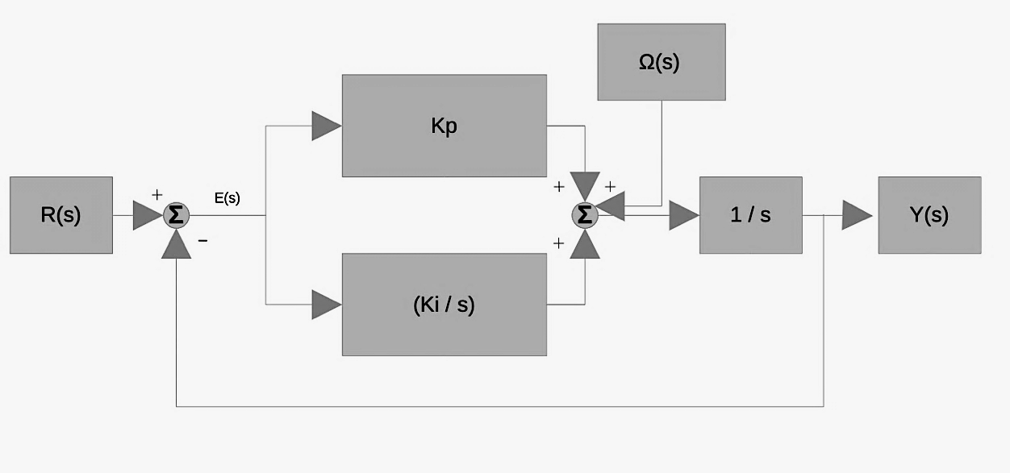

Transfer Function | Standard 2nd order
$$Y\left(s\right)=\frac{K_{p}s+K_{i}}{s^{2}+K_{p}s+K_{i}}R\left(s\right)+\frac{s}{s^{2}+K_{p}s+K_{i}}Ω\left(s\right)$$  $$Y\left(s\right) :estimated attitude angle$$  $$R\left(s\right) :accelerometer-derived attitude reference$$  $$Ω\left(s\right) :Measured gyro angular rate,\frac{rad}{s}$$ | $s^{2}+2ζw_{n}s+w_{n}^{2}=s^{2}+K_{p}s+K_{i}$  $$K_{i}=w_{n}^{2}$$  $$K_{p}=2ζw_{n}s$$  $$ζ=\frac{K_{p}}{2√K_{i}}→Damping$$  $$w_{n}=\sqrt{K_{i}}→filter correction bandwidth$$

Understanding the Equations:

$$Y\left(s\right)=\frac{K_{p}s+K_{i}}{s^{2}+K_{p}s+K_{i}}R\left(s\right)+\frac{s}{s^{2}+K_{p}s+K_{i}}Ω\left(s\right)$$

Y(s) is the frequency response of the system where R(S) is the accelerometer input and Ω(s) is the Gyro input. The inputs are independent and can be solved for output using superposition, a very important key feature can be expressed easily, that is the signal frequency response which the system has towards each input. By taking Y(s)/R(s) you get the frequency response of the accelerometer and by taking Y(S)/ Ω(s) you get the frequency response of the gyro, since Gyro is in rads/sec its good to express as angle input.

Defining the Transfer functions:

$$\frac{Y\left(s\right)}{R(s)}=\frac{K_{p}s+K_{i}}{s^{2}+K_{p}s+K_{i}} \frac{Y\left(s\right)}{Ω\left(s\right)}=\frac{s}{s^{2}+K_{p}s+K_{i}}$$

$$θ_{g}\left(s\right)=\frac{Ω\left(s\right)}{s}→Ω\left(s\right)= θ_{g}\left(s\right)*s \frac{Y\left(s\right)}{θ_{g}\left(s\right)}=\frac{s^{2}}{s^{2}+K_{p}s+K_{i}}$$

Acc frequency response | Gyro(integrated angle) frequency response
$${\left(\frac{Y\left(s\right)}{R\left(s\right)}\right)}_{\lim{→0}}= 1$$ | $${\left(\frac{Y\left(s\right)}{θ_{g}\left(s\right)}\right)}_{\lim{→0 } }=0$$
$${\left(\frac{Y\left(s\right)}{R\left(s\right)}\right)}_{\lim{→}∞}= 1$$ | $${\left(\frac{Y\left(s\right)}{θ_{g}\left(s\right)}\right)}_{\lim{→∞ } }=0$$

